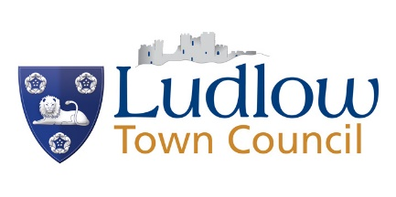

WE NEED YOUR THOUGHTS ON
ELECTRIC VEHICLES!

The Government plans to stop the sale of all petrol and diesel cars by 2035 at the latest and will permit only electric cars on public roads after 2050. To encourage more motorists to switch to electric vehicles they are offering grants to enable the installation of public charging points for Electric Vehicles [EVs].

Ludlow Town Council is therefore considering approaching Shropshire Council regarding the installation of EV charging points on public roads in our town.
We are working in collaboration with Ludlow 21 Sustainable Transport Group on this project.

We want to know whether you think this is a good idea – especially in your neighbourhood!

Please answer the following questions and return this form, no later than Wednesday 16th December by:
Post – to the Buttercross, King Street Street, Ludlow, SY8 1AW or
Email – kate.adams@ludlow.gov.uk
If you have any queries please call the office on 01584 871 970.

Q1 | Do you own an electric vehicle? | Yes (go to Q2)  No (go to Q3)
Q2 | If yes is it a) a full electric vehicle or b) a hybrid vehicle? | - Full electric  - Hybrid
Q3 | If no to Q1, do you plan to buy an electric vehicle? | Yes within the next 6 months
 |  | Yes within the next two years
 |  | No
Q4 | Can you park your car off the road, on your own property? | Yes  No
Q5 | Do you think on street charge points should be installed in Ludlow? | Yes  No
 | If yes, on which street/s do you feel it would be most useful to have a charging point?
Q6 | Do you believe that on street charging points would bring passing tourists in to Ludlow? | Yes  No
Q7 | Would a lack of public charging points delay your purchase of an electric vehicle (if you haven’t yet got one)? | Yes  No
Q8 | Would you consider using an electric car share scheme if one was implemented locally? | Yes  No
Q9 | Do you have any further comments?

OPTIONAL If you would like to be kept informed of progress, please provide your name, address and email details.

Q10 | Name :
 | Address:
 | Email address (please print):

To comply with GDPR information from Q10 will be kept securely and only used for the purpose above. You can request your information to be deleted at any time by contacting Ludlow Town Council. The full list will be deleted in November 2021.

